Informationen für APPSTORE

BASE INFORMATION
Vendor |  | GPS GmbH
Name |  | STYLE
Description
Short Description |  | Layout Examples
Public | Publicly visible to everyone | true
Allowed Serials | List of serial numbers that are allowed to download the app, leave empty array if public | []
Initial App Version |  | V1.0.0
Version Channels | Availability of app | Alpha, Beta, Stable
Icon Fallback | Chosen from Material icons | style
Vendor Logo | 192x192 or 256x256  svg or png  Currently unused | 
Pictures | jpg 1920x1080 | 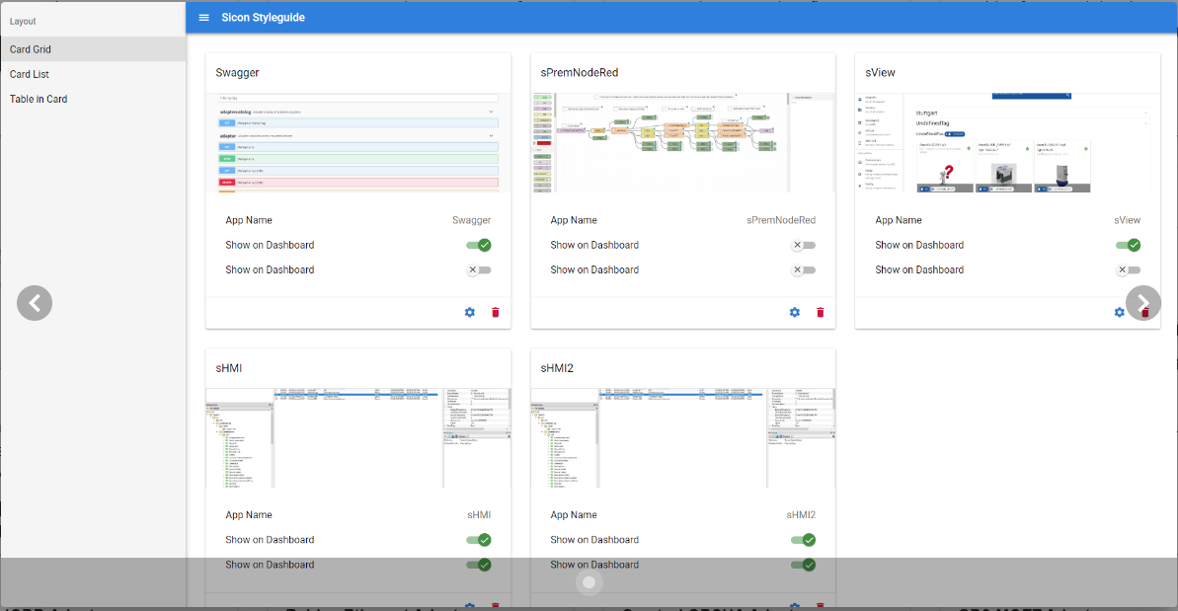
LICENSE INFORMATION
Licence Type | GPS APP EULA
Max. Count of Installations | 1
Price | 0€
Technical Information
Typ | Adapter, Connector, App
App-Store User E-Mail | horst@entwickl.er
SICON-Communication | OPC UA
SICON-API Version | V1.0
Technical Description | Das was die app eben macht
Docker Registry URL |  | registry.service.sicon.eco
Docker Registry Name
Docker Registry Password
Docker Image | Namespace – Take vendor/app-name (will also be used for app url on SICON.OS) | sicon/style
RunSettings | Docker Settings for additional ports. (default: 80)  See link  List of illegal settings:  Links  Privileged  NetworkMode  SecurityOpt  StorageOpt  CgroupParent  VolumeDriver | {}

